Homework 3 – Integrate and calculate the error of the following integral:

$$\int_{-1}^{1}{\left[4x^{3}+3x+1\right]dx}$$

# Evaluating the integral with just calculus, the result is shown:

$${\left.{\int_{-1}^{1}{\left[4x^{3}+3x+1\right]dx}=x}^{4}+\frac{3}{2}x^{2}+x\right|}_{-1}^{1}=\left[{\left(1\right)}^{4}+\frac{3}{2}{\left(1\right)}^{2}+\left(1\right)\right]-\left[{\left(-1\right)}^{4}+\frac{3}{2}{\left(-1\right)}^{2}+\left(-1\right)\right]=2$$

The error for this method is none since it is the integral value.

# Evaluating the integral via the trapezoidal method with intervals of .05:

$$\int_{-1}^{1}{f\left(x\right)dx}≈$$

$$\left[\frac{1}{2}f\left(-1.00\right)+f\left(-0.95\right)+f\left(-0.90\right)+…+f\left(0.00\right)+…+f\left(0.90\right)+f\left(0.95\right)+\frac{1}{2}f\left(1.00\right)\right]$$

$$=\left[\frac{1}{2}*\left(-6.00\right)+\left(-5.28\right)+\left(-4.62\right)+…+\left(1\right)+…+\left(6.62\right)+\left(7.28\right)+\frac{1}{2}\left(8.00\right)\right]$$

Using the following program:

#include <iostream>

#include <cmath>

#include <iomanip>

using namespace std;

int main()

{

long double i = -1, f = 1, f_x = 0, dx = .05, Sum = 0, Integral = 0;

long double f_i = 4 * pow(-1, 3) + 3 * (-1) + 1;

while (i < (f - dx))

{

i = i + dx;

f_x = 4 * pow(i, 3) + 3 * i + 1;

Sum = Sum + f_x;

};

long double f_f = 4 * pow(1, 3) + 3 * (1) + 1;

Integral = (.5*f_i + Sum + .5*f_f)*dx;

cout << Integral << endl;

return 0;

}

The result is that no matter what dx is chosen, the integral value will always be 2, as long as the dx can properly divide the interval.

# Evaluating the integral via Simpson’s Rule:

$$\int_{-1}^{1}{f\left(x\right)dx≈\frac{f\left(1\right)}{3}+\frac{4f\left(0\right)}{3}+\frac{f\left(-1\right)}{3}=\frac{\left[8.00\right]}{3}+\frac{4*\left[1\right]}{3}+\frac{\left[-6.00\right]}{3}=2}$$

The Simpson’s Rule seems to give the same answer like the other two methods.

# Final Comments:

Because of the nature of the integral in the interval it is in:

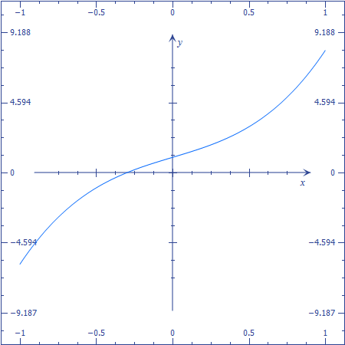

It is almost linear and that is why all the integration methods have been showing to be this accurate. The error is 0 only because of this almost linear behavior.